Valgrind installation:-

1) Downloaded the files required for for valgrind, ref path (“http://valgrind.org/downloads/current.html”)
2) execute ./configuration for checking configuration before the installation
3) make , to compile the package.
4) “sudo make install” install the program.

- Write a simple program that allocates memory using malloc() but forgets to free it before exiting. What happens when this program runs? Can you use gdb to find any problems with it? How about valgrind (with the command: valgrind --leak-check=yes null)?
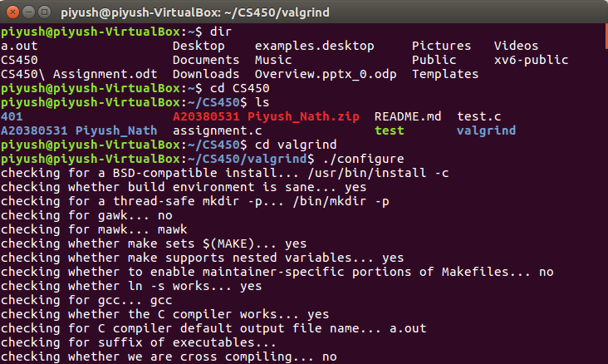
Once the Installation is done, We will create a demo c program to observe how gdb works for debugging our program.

We wrote a code to allocate memory to a variable and later free that memory in mallocTest.c.
When we free the space and execute valgrind ,it gives us the detailed output which also checks if there is any memory leak observed. These things are very hard to get caught when using gbd ,debugger.

Valgrind great in detecting memory leakage or when system picking up unwanted data. Valgrind helps us in improving the performance of the program ,but gdb is a great tool to find the on run values for finding the rootcause and quick debugging of the program.

Debugging using gbd:

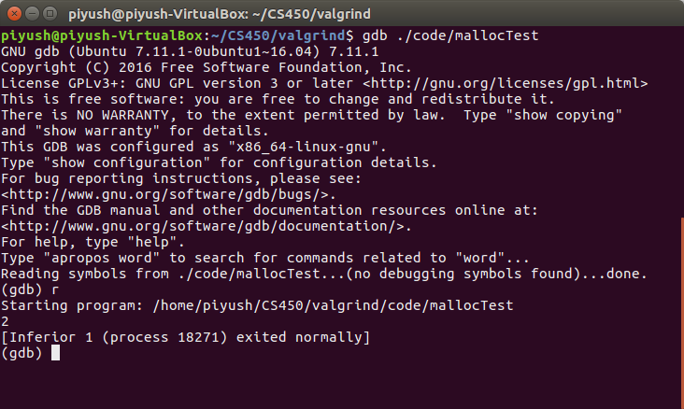
Here in our problem ,though we are not freeing any space which had been allocated using malloc in our mallocTest program,our debugger ran successfully without giving any error, but we know that we haven’t released the memory.

Debugging using Valgrind:
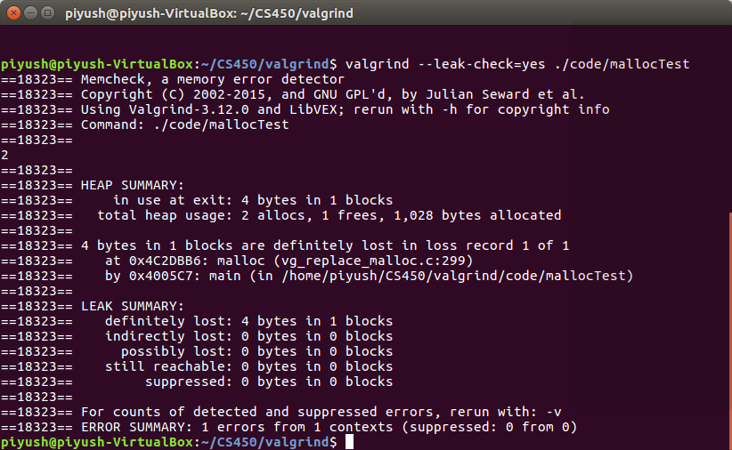
The above mentioned output by valgrind shows us that tool was able to detect the leaked memory. Though note that we have added extra –leak-check=yes which will show that as an error. Even though we can see the Leak summary in case of memory leak is there.
This might not feel that helpful,as we are OK if we miss out 1 or 2 byte of memory as its not impacting our output. But as we grow, we might be working on huge chunk of memory and its very difficult to detect ,that if our program is not leaking memory or is efficient enough.

- Create a program that allocates an array of integers called data of size 100 using malloc, frees them, and then tries to print the value of one of the elements of the array. Does the program run? What happens when you use valgrind on it?
We created a program called progAccessFreeVar.c where we are allocating array of size 100 to a variable ptr. Later we assigned the values as per their array position.
Later we freed the space,though we ran the program it gave us the expected output. Reason is,even though we freed the memory doesn't mean the data is lost, but its not sure that the data will be consistent,there can junk data. But in program where we are using only less lines of code,the possibility of getting junk is less. But there can be case when we will get junk as ouput. Then its very difficult to debug the problem, in that scenario valgrind comes handy as when we executed the code using valgrind we got below output.
Let us run valgrind to see the output for the same program.
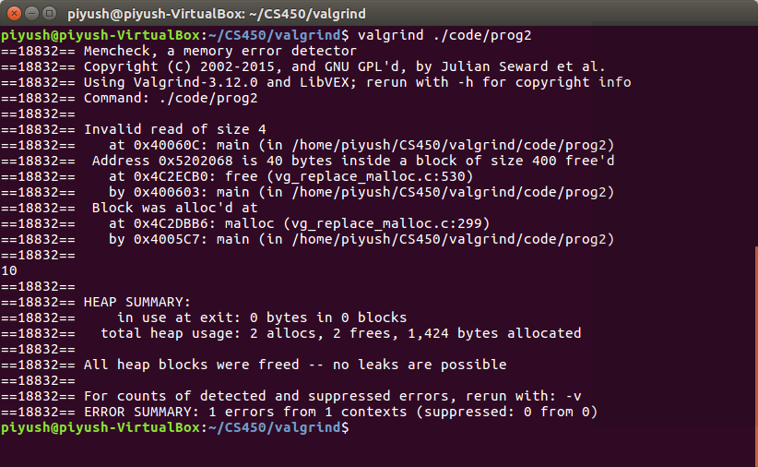
Here we can see,code detected invalid read of size 4. as we are trying to access one integer.
Code:
int *ptr;
ptr =(int *)malloc(ARRAYSIZE*sizeof(int)); //Initialize memory to array with size 100
for(int j = 0; j < ARRAYSIZE; j++)
ptr[j]=j; //set the value to each of the array item
free(ptr); //free the memory as per requirement before using an element.
printf("%d\n",ptr[10]); //print a array data
return 0;

STEPS TO EXECUTE:
- Extract code from “Part 2 code” folder and keep where valgrind is kept.
- For 2 a, execute program “mallocTest” with valgrind. Instruction set “valgrind –leak -check=yes ./mallocTest”
- For 2 b execute program “prog2” with valgrind . Instruction set “valgrind ./prog2”.

